**Section 1**

**Instructions**

* Choose the best answer for Questions 1-10.
* This section has 10 questions and is worth 10 marks.
* Use a 2B pencil to fill in the A,B,C or D answer bubble completely.
* If you change your mind or make a mistake, use an eraser to remove your response and fill in the new answer bubble completely. 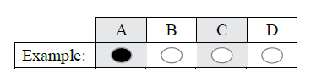



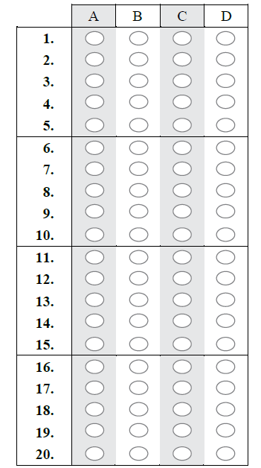

**QUESTION 1**

In humans, most nutrients are absorbed in the

(A) stomach

(B) small intestine

(C) large intestine

(D) both small and large intestine

(E) mouth

**QUESTION 2**

 All cells have a cell surface membrane. Cell surface membranes regulate the movement of substances into and out of cells. Which of the following describes the movement of water by osmosis?

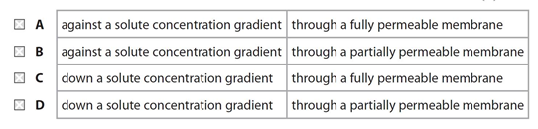

**QUESTION 3**

Glucose enters cells by facilitated diffusion.

Which part of the cell surface membrane allows facilitated diffusion of glucose?

**A** cholesterol

**B** glycolipid

**C** phospholipid

**D** protein

**QUESTION 4**

A plant cell is placed into pure water. Which of the following will occur?

(A) Water will flow into the cell because the water potential inside the cell is higher than it is outside the cell.

(B) Water will flow into the cell because the water potential inside the cell is lower than it is outside the cell.

(C) Water will flow out of the cell because the water potential inside the cell is lower than it is outside the cell.

(D) Water will flow out of the cell because the water potential inside the cell is higher than it is outside the cell.

**QUESTION 5**

Refer to the following diagrams of cubes which represent different cells A, B and C

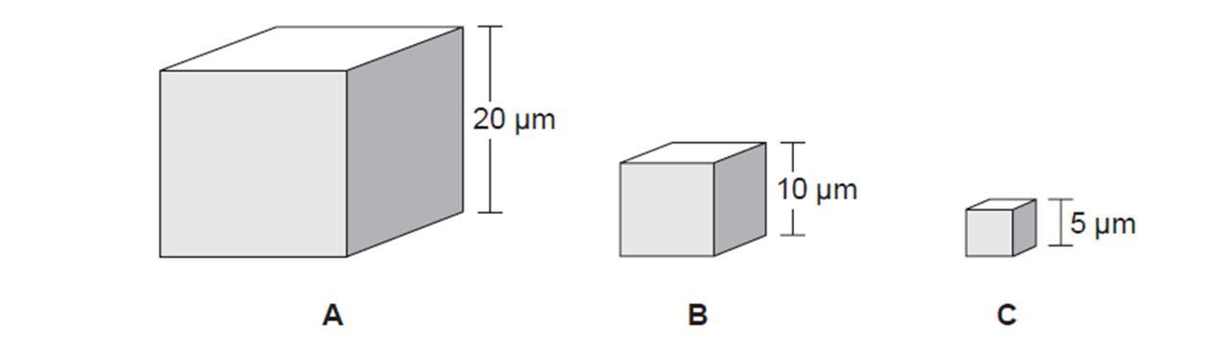

Which one of the following statements **identifies** the relative efficiency of these cells in the exchange of materials?

1. Cell A is more efficient than cell B, but less efficient than cell C.
2. Cell B is less efficient than cell A, but more efficient than cell C.
3. Cell A is less efficient than cell B and cell C.
4. Cell C is less efficient than cell A and cell B.

**QUESTION 6**

Eukaryotic and prokaryotic cells both produce enzymes.

Which of the following pairs of statements is true for eukaryotic and prokaryotic cells?

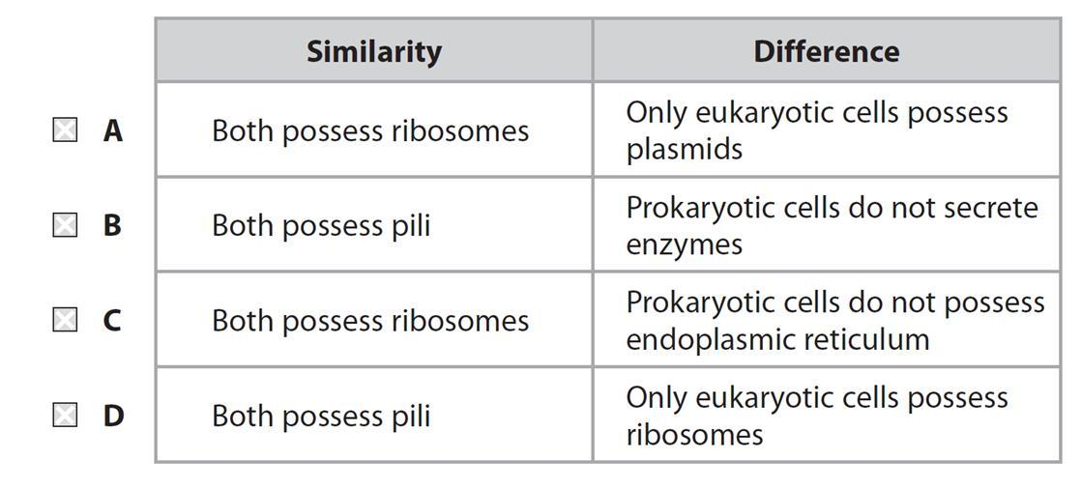

**QUESTION 7**

Which of the following is *not* normally found in a plant cell?

(A) mitochondria

(B) endoplasmic reticulum

(C) plastids

(D) centrioles

**QUESTION 8**

Transpiration in plants requires all of the following EXCEPT

(A) cohesion of water molecules

(B) active transport of water molecules in the xylem

(C) capillary action of water in the xylem

(D) evaporation of water

**QUESTION 9**

Which one of the following would *not* normally diffuse through the lipid

bilayer of a plasma membrane?

(A) CO2

(B) amino acid

(C) starch

(D) water

**QUESTION 10**

An animal cell in a hypertonic solution would

(A) swell

(B) swell and exhibit turgor

(C) exhibit plasmolysis

(D) shrink and then swell

**SECTION 2**

**Instructions**

• Write using black or blue pen.

• Respond in paragraphs consisting of full sentences unless otherwise instructed.

• If you need more space for a response, use the additional pages at the back of this book. On the additional pages, write the question number you are responding to.

Cancel any incorrect response by ruling a single diagonal line through your work.

Write the page number of your alternative/additional response, i.e. See page …

If you do not do this, your original response will be marked.

**QUESTION 11**

The diagram below shows the general structure of an animal cell as seen under an electron microscope.

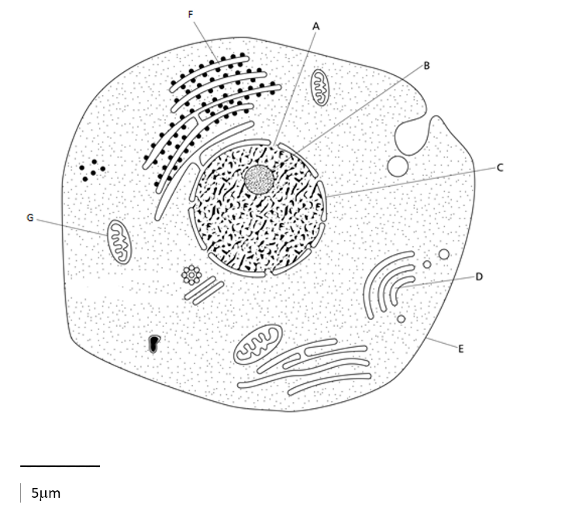

Label the cellular structures (A-G):

|  |  |
| --- | --- |
|  |  |
|  |  |
|  |  |
|  |  |

**QUESTION 12**

1. Write the equation for photosynthesis.
2. Complete the following diagram of the stages of photosynthesis.

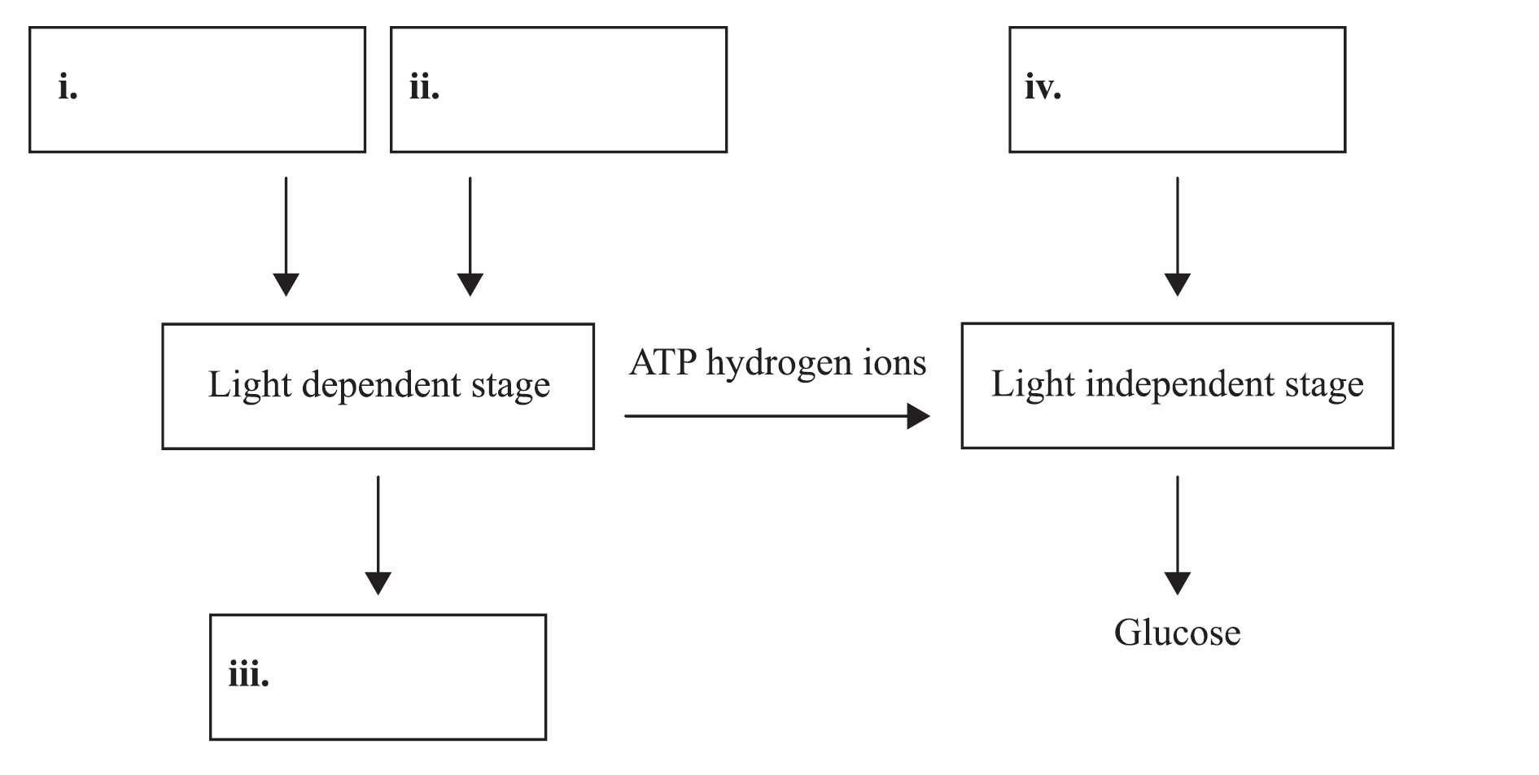

**QUESTION 13**

The diagrams below represent the vascular system of a flowering plant.

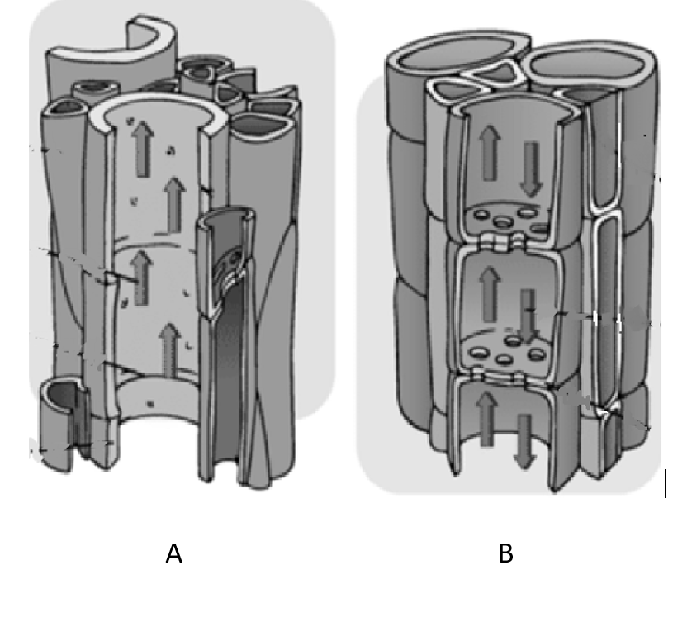

1. Identify the tissues illustrated in images A and B.
2. Name a substance transported in tissue A.
3. Name a substance transported in tissue B.
4. Arrows in the images demonstrate the direction of flow of material within the vascular tissue. Explain why arrows in tissue A are one-directional where as in image B they point in both directions.

**QUESTION 14**

The electro-micrograph below shows a portion of a cell.

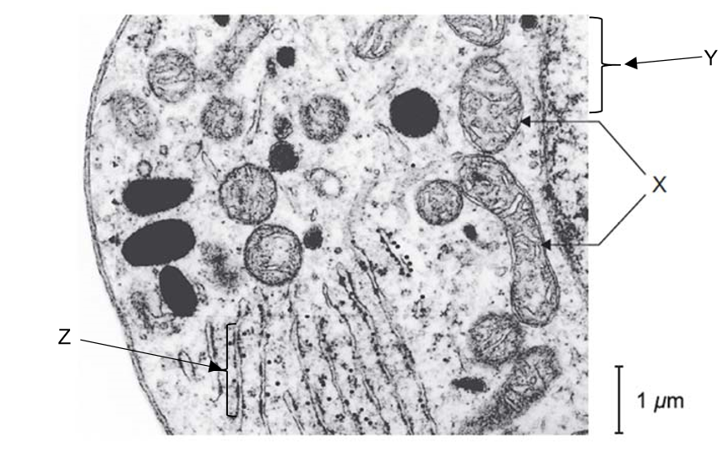

1. Identify the organelles indicated by the arrows Y and Z.
2. Identify TWO features that indicate this is an animal cell.
3. Given the large number of organelles X and Z, what does this suggest about the function of the cell? Explain.

**QUESTION 15**

Although photosynthesis is often summarised by a single equation, in fact the process occurs in two distinct phases; the light phase and the light independent phase. These two phases can be summarised in diagrammatic form as follows.

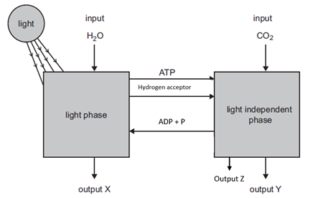

The diagram shows outputs X, Y and Z.

1. **Identify** output X
2. Briefly **explain** how X is produced
3. **Identify** output Z and Y